Schools must use the funding to make additional and sustainable improvements to the quality of PE and sport they offer. This means that you should use the Primary PE and Sport Premium to:

- develop or add to the PE and sport activities that your school already offers
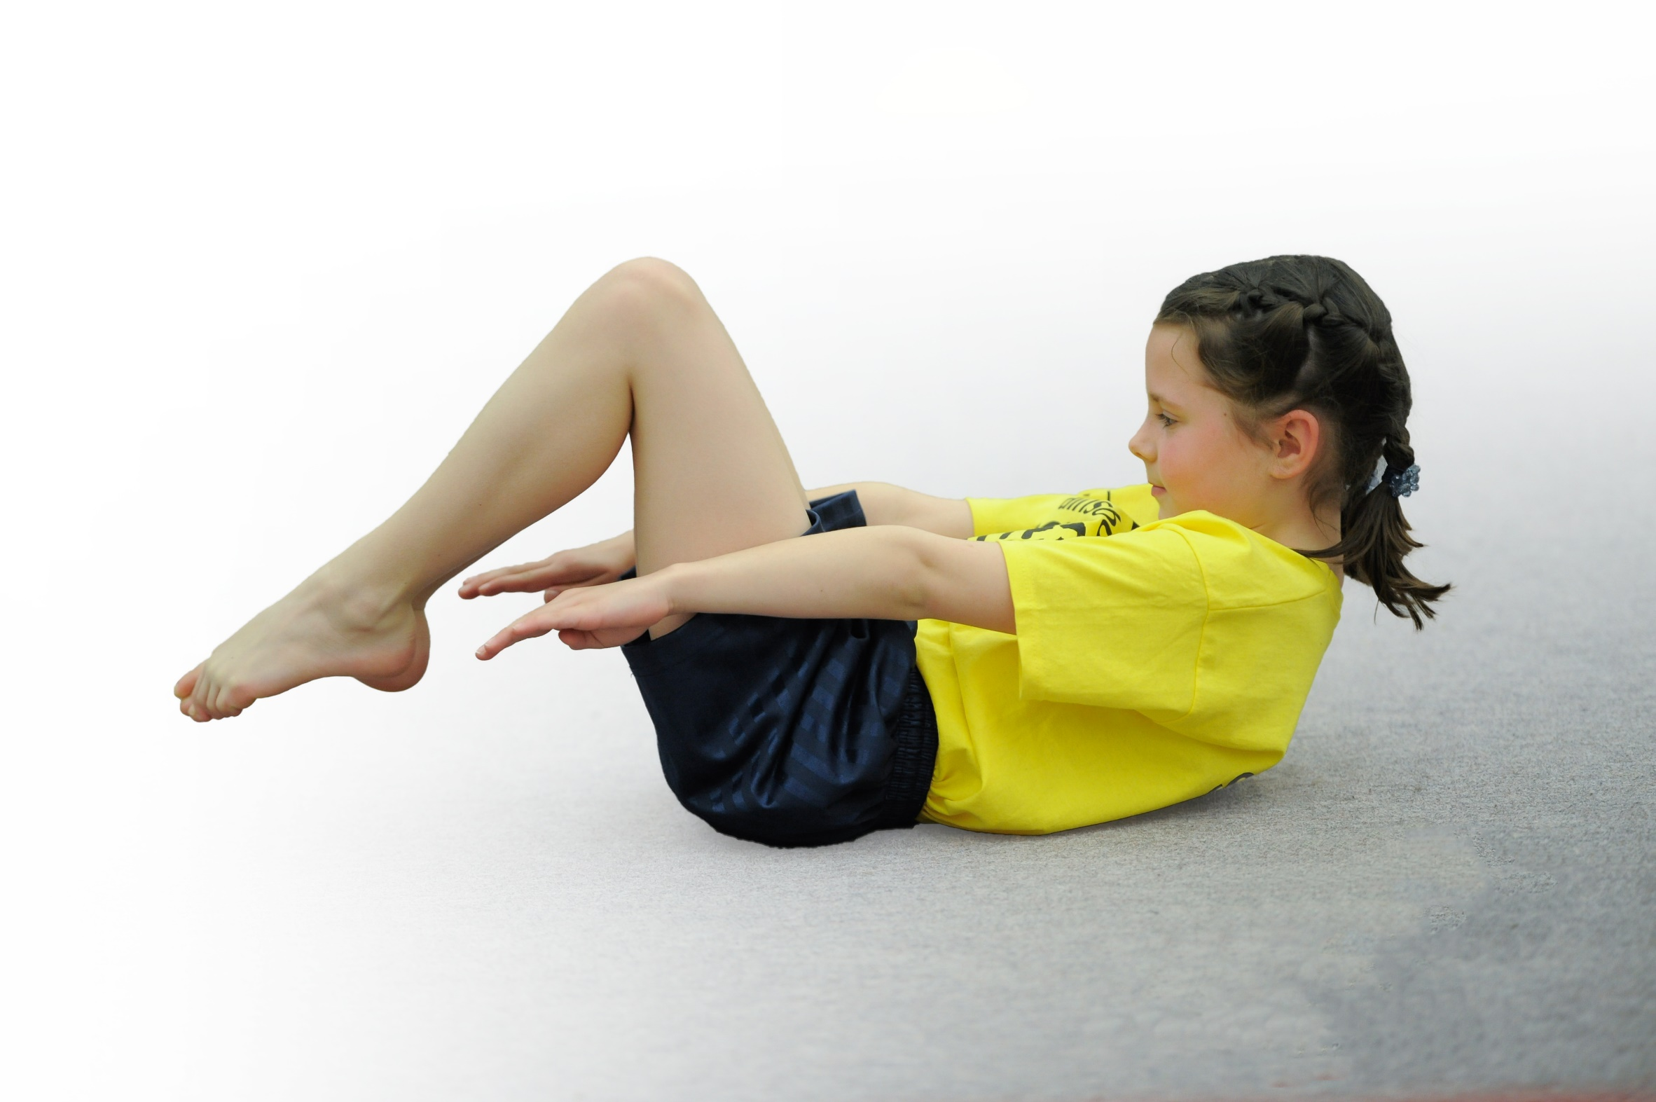
- build capacity and capability within the school to ensure that improvements made now will benefit pupils joining the school in future years

Please visit gov.uk for the revised DfE guidance including the 5 key indicators across which schools should demonstrate an improvement. This document will help you to review your provision and to report your spend. DfE encourages schools to use this template as an effective way of meeting the reporting requirements of the Primary PE and Sport Premium.

We recommend you start by reflecting on the impact of current provision and reviewing the previous spend.
Under the Ofsted Schools Inspection Framework, inspectors will assess how effectively leaders use
the Primary PE and Sport Premium and measure its impact on outcomes for pupils, and how effectively governors hold them to account
for this.

Schools are required to publish details of how they spend this funding as well as on the impact it has on pupils’ PE
and sport participation and attainment.
We recommend regularly updating the table and
publishing it on your website as evidence
of your ongoing review into how you are using the money
to secure maximum, sustainable impact. To see an example of how to complete the table please click HERE.

Support for review and reflection - considering the 5 key indicators from DfE, what development needs are a priority for your setting and your students now and why? Use the space below to reflect on previous spend, identify current need and priorities for the future.

Key achievements to date: | Areas for further improvement and baseline evidence of need:
Improved quality of teaching a varied PE curriculum indoor and outdoor.  Introduction into the curriculum of outdoor and adventurous teaching  Improved access to competition and increased numbers involved  Active learning in lessons  Development of Y5 play leaders  Development of WCM marathon  Development of healthy lifestyles target of less active pupils | Assessment  Maintain and further improve quality of teaching  Access training for teachers when needed  Make better links to whole school improvement  Achieve Gold Sports Mark

Meeting national curriculum requirements for swimming and water safety | Please complete all of the below*:
What percentage of your current Year 6 cohort swim competently, confidently and proficiently over a distance of at least 25 metres? | 57%
What percentage of your current Year 6 cohort use a range of strokes effectively [for example, front crawl, backstroke and breaststroke]? | 57%
What percentage of your current Year 6 cohort perform safe self-rescue in different water-based situations? | % Unknown
Schools can choose to use the Primary PE and Sport Premium to provide additional provision for swimming but this must be for activity over and above the national curriculum requirements. Have you used it in this way? | Yes/No

Action Plan and Budget Tracking
Capture your intended annual spend against the 5 key indicators. Clarify the success criteria and evidence of impact that you intend to measure to evaluate for students today and for the future.

Academic Year: 2018/19 | Total fund allocated: £19,870 | Date Updated:
Key indicator 1: The engagement of all pupils in regular physical activity – Chief Medical Officer guidelines recommend that primary school children undertake at least 30 minutes of physical activity a day in school |  |  |  | Percentage of total allocation:
 |  |  |  | %
School focus with clarity on intended impact on pupils: | Actions to achieve: | Funding allocated: | Evidence and impact: | Sustainability and suggested next steps:
Opportunities in school to ensure all pupils undertake 30 minutes of activity a day in school  Encourage children to lead a healthy and active lifestyle outside of the school day. | - Y5 Play leaders trained  - Adult play leaders CPD (completed Oct 2019.)  - Lunchtime physical activity programme set up  - Intra school/ inter form competitions  - Scootering, bikes, football with SWFC and nerf during golden time  - WCM Marathon during lunchtimes  - Lunchtime clubs  - Afterschool PA clubs  - 2-3 physical activity afterschool clubs each night  - Signpost children to clubs after school – partnerships with SUFC, SWFC, Cycle Speedway.  - SHINE project for Y6 in curriculum time.  - Residential activities (low ropes, cycling Mosal Trail) |  | - Watercliffe Marathon over 320 children taking part 103 completed this year.  - Incorporated a mile a day challenge.  - Wide variety of sports on offer and a varied programme of sporting opportunities  - Lunchtime clubs- children playing invasion games and having intra form matches  - Active lessons  - Play leaders organising play activities outside for younger children.  - Children attending events and games at stadiums, training grounds and had the opportunity to access live games and events (Sheffield Shark Matches, DanceDaze Dance competition).  - Change4life opportunities for children who don’t play sport outside of school. A commitment to giving these children the opportunities of good coaching and competitive tournaments.  - An increasing number of children involved in competitions.  - Wheelie Wednesday.  - Y4 and Y6 receive Learn2Ride sessions and Y5 complete Bike It. | - Continue to monitor children running the WCM marathon.  - Set up a family marathon session before and after school  - Further develop the 30 active minutes through playground activities run by the play leaders  - Continue to offer a varied programme of  social and lunchtime activities to support 30 active minutes.
Key indicator 2: The profile of PE and sport being raised across the school as a tool for whole school improvement |  |  |  | Percentage of total allocation:
 |  |  |  | %
School focus with clarity on intended impact on pupils: | Actions to achieve: | Funding allocated: | Evidence and impact: | Sustainability and suggested next steps:
Embed a love of sport and continue to ensure sport is high profile in the school. | - Play leaders to develop sport and have a say in what children want in terms of physical activity in school  - PE blog to celebrate all of the sporting experiences and successes  - PE/ School Games display board to celebrate GT performers, success in matches and competitions.  - We currently hold the ‘Bronze’ Sports Mark award.  - Zoning of playground through School Council. |  | - PE PDM CPD for all staff.  - Yearly Dance CPD with Dancedaze who team teach with a different year group each half term  - WCM Marathon daily  - School Games Competitions  - BBraun Competitions  - SFSS membership and competitions  - Active classrooms, active 8, go noodle.  - Children experienced live matches and competitions- Performed at half time of Sheffield Sharks Basketball match.  - Celebrate sporting achievement via the PE blog | - Staff to have continuous access to CPD in PE and Sport.  - Celebrate sporting achievements weekly in school assemblies.  - Provide evidence for sporting achievements in school into children’s University folders.

Key indicator 3: Increased confidence, knowledge and skills of all staff in teaching PE and sport |  |  |  | Percentage of total allocation:
 |  |  |  | %
School focus with clarity on intended  impact on pupils: | Actions to achieve: | Funding  allocated: | Evidence and impact: | Sustainability and suggested  next steps:
Staff continue to access training opportunities in PE and school sport. | - Subject lead to attend Arches network meetings September 2019 and January 2020.  - Various city wide PE and Sport training opportunities have been offered to all staff.  - Our play leaders had refresher on playground games October 2019.  - All staff to be offered CPD in areas they are teaching but are not trained in  - Planning for PE – following the yearly overview for PE.  - PE lead to monitor lessons  - School council to have a focus on PE and Sport- giving children a voice through school circles.  - School has positive club links and works with SUFC, SWFC, Cycle Speedway, Dance Daze and orienteering to upskill teachers.  - Staff members trained up to run Shine Programme (change 4 life) for underweight and overweight children within school. |  | - Dance Daze, SWFC and Cycle Speedway provide excellent CPD and training and team teach for staff.  - Training opportunities timetable for CPD offered to all staff via the Arches School Sport Partnership and included in our yearly plan. | - Continue to offer CPD for all staff when and if required.
Key indicator 4: Broader experience of a range of sports and activities offered to all pupils |  |  |  | Percentage of total allocation:
 |  |  |  | %
School focus with clarity on intended  impact on pupils: | Actions to achieve: | Funding  allocated: | Evidence and impact: | Sustainability and suggested  next steps:
School to include opportunities for children to try out a range of sports both within curriculum lessons, lunch time and after schools clubs.  Dance Daze team teaching on different and current styles of dance. | Develop orienteering- Pauline Tryner (SYO development Coach) came in and set up a trail in school October 2017.  Dance Daze instructor in school every Monday morning to work with Y1-Y6 classes and team teach with teachers. | £500  £1710 | - Y5’s orienteering day at Hillsborough Park.  - Orienteering added into summer term planning Y3-Y6.  - Children experienced a range of dance styles  - Teachers have got more ideas and skills to teach dance. | Children received a Lifecard with reduced skating lessons to help support school to club links.
Key indicator 5: Increased participation in competitive sport |  |  |  | Percentage of total allocation:
 |  |  |  | %
School focus with clarity on intended  impact on pupils: | Actions to achieve: | Funding  allocated: | Evidence and impact: | Sustainability and suggested  next steps:
Offer a wide range of competitions inside and outside of school so children learn how to enjoy competition/ be competitive and take this into life outside school. | Involvement in school games activities  Release staff to run / lead teams  Access to clubs leading to competitions and performance  Develop opportunities in alternative sports e.g. Rock climbing/boccia.  Offer access to sports in school through external coaches SWFC, Dance Daze, Arches, Cycle Speedway.  Intra school sports continue to develop and embed a love of competing. | Travel to competitions  Entry fees to competitions  Arches SSP  SFSS entry £60  Arches - £2250 | - Attendance at School Games and Arches Competitions. Received Bronze School Games Mark Award. | - Continue to support travel to events through sports funding  - Continue to log participation so that all children get the chance to experience competition  - Continue to release staff to attend competitions

